Project Specification
Project#TR26-0001-BTS Global Testing – India

Original Date: | 05/01/2026 | Revision Date: | DD/MM/YYYY | Revision No. | 0

Project Title | 50x64x6HMSA10RG Seal Mud & Slurry Test with Oil fill
Requested By | Abbas Taher | Project Leader | Anoop N

Estimated Time for Project

Activity | Duration
Tooling Design, Manufacture and Inspection | 2 weeks
Testing 2 Seals 56 Hrs. each | 2 weeks
Analysis & Reporting | As per agreed date in TEEXMA

* Test Seal samples shall be delivered to test center. It is preferred to receive the test samples along with Inspection report

Objective

To Conduct the Mud & Slurry Test with Oil fill on 2 samples of 50x64x6HMSA10RG shaft seal.

Expected outcome from the Project

To check whether the seals fulfill the customer’s requirement, when tested as per the specification received from SKF Sealing Solutions, India

Test Specification
Shaft: Steel 1045 - LDS
Diameter: 49.920 ± 0.080 mm
Surface Finish: 0.2 ~ 0.5 µm Ra
Hardness: 35 HRC Min.
DRO: 0.250 ± 0.025 mm TIR
Direction of Rotation: Refer Test cycle

Bore: Steel C-1018 - STD
Diameter: 64.023 ± 0.023mm
STBM: 0.000 ± 0.025 mm TIR
Surface Finish: 1.6 ~ 2.5 µm Ra
STBM Orientation: Minimum interference at 6 O'clock
Seals cock: 0.150 ± 0.025 mm
Reciprocation: 0.000 ± 0.000 mm

Fluid:
Type – SAE 80W90 TATA
Fluid Level – Shaft Center line
Temperature: Refer Test Cycle
Oil Change Interval: N/A
Pre-lube: Prelube - 3 drops of oil on the shaft

Slurry Mixing:
Type: ISO 12103-1 A2 Dust + Water
Mix Ratio: 1:10
Amount: Below Shaft Level
Recip. Frequency: N/A

Test Procedure:

- Pre and Post-test measurements of Seals are as follows,

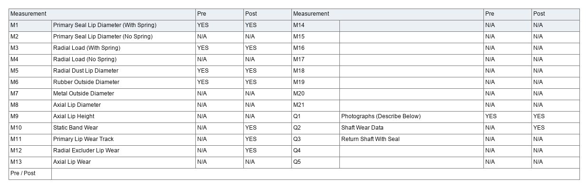
- Tolerance for Speed is ± 50 RPM and Temperature is ± 5°C

- Test cycle would be as follows:
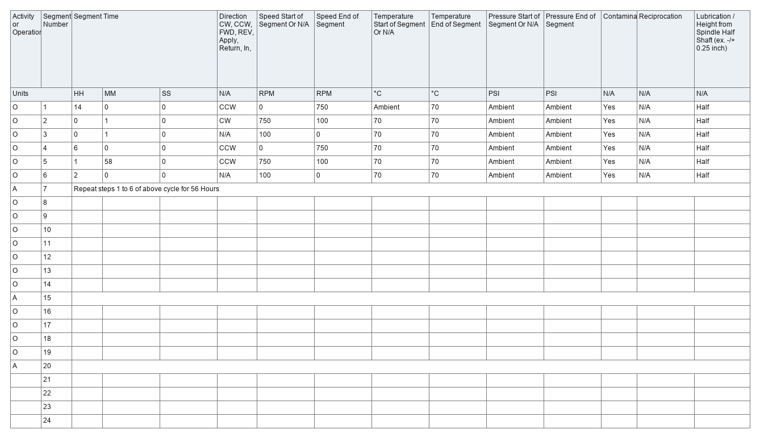
- The total test duration is 56 Hours
- Test setup and seal photographs shall be shared in the test report.

Acceptance Criteria:

- No Mud Entry / No lip hardening / No cracks or damages on the lip

Product Drawing:
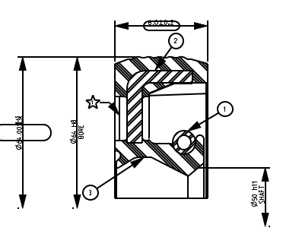

Procedure for monitoring:

- Each day in the morning between 8 a.m. and 9 a.m. to examine the seal (At the interference between the shaft OD and the seal ID, at interference between the bore ID and the seal OD) area for the oil seepage or leakage which constitutes a failure.
- On Friday of every week, the observation will be made again between 3.30 pm to 4.30 pm.
- During the weekend (Saturday & Sunday) and public holidays, the visual inspection cannot be done and any leakage found on the next inspection day, the total hours accumulated will be considered as the previous inspected completed hours.

Disclaimer:
Seals dimensional results will be reported as actual and no inference will be made on the results.

